Exp 13
```matlab
clc;
clear;
close all;

fm = 50;
T = 0.06;
dt = 1e-5;
t = 0:dt:T;
x = cos(2*pi*fm*t);

fs_list = [0.5*fm, fm, 2*fm, 5*fm, 10*fm];

labels = {'fs = 0.5 fm (aliased)', ...
'fs = fm (under-sampled)', ...
'fs = 2 fm (Nyquist rate)', ...
'fs = 5 fm (over-sampled)', ...
'fs = 10 fm (over-sampled)'};

% Sampling at different rates
figure('Name','Sampling at Different Rates');

for k = 1:length(fs_list)
fs = fs_list(k);
n = 0:1/fs:T;
xn = cos(2*pi*fm*n);

subplot(length(fs_list),1,k);
plot(t,x,'b','LineWidth',1);
hold on;
stem(n,xn,'r','filled');
title(labels{k});
xlabel('t (s)');
ylabel('x(t)');
end

% Sinc reconstruction and error
fprintf('Nyquist rate (2*fm) = %.2f Hz\n',2*fm);
err = zeros(size(fs_list));

for k = 1:length(fs_list)
fs = fs_list(k);
n = 0:1/fs:T;
xn = cos(2*pi*fm*n);
x_recon = zeros(size(t));

for i = 1:length(n)
x_recon = x_recon + xn(i)*sinc(fs*(t-n(i)));
end

err(k) = mean(abs(x-x_recon));

fprintf('fs = %6.1f Hz (fs/fm = %4.1f) -> mean reconstruction error = %.5f\n', ...
fs,fs/fm,err(k));
end
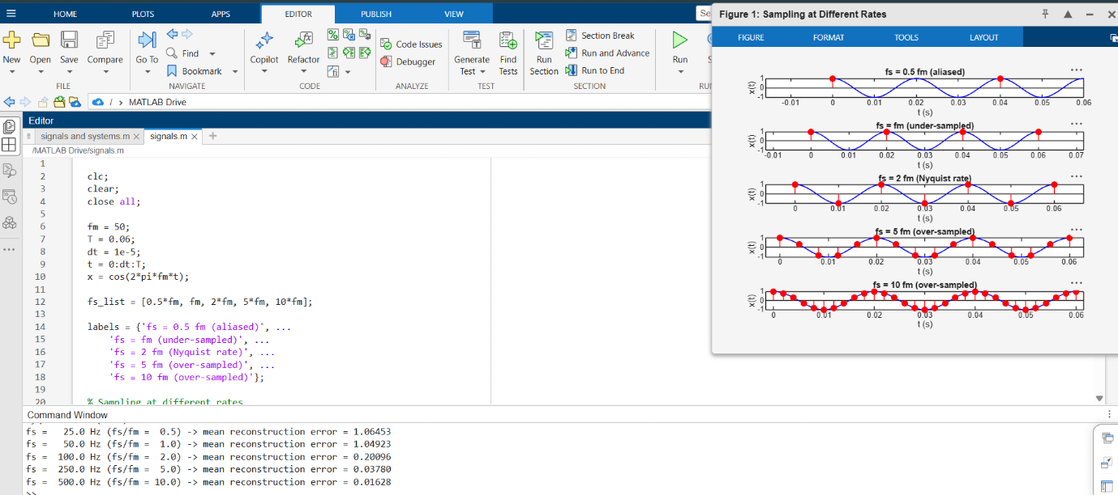
Exp 15
clc; clear; close all;

N = 10;
n = 0:N-1;
x = ones(1,N);
w = linspace(-pi,pi,1024);

% DTFT
X = zeros(size(w));
for k = 1:length(w)
X(k) = sum(x.*exp(-1j*w(k)*n));
end

% Magnitude and phase spectra
figure;
subplot(2,1,1);
plot(w/pi,abs(X)); grid on;
xlabel('\omega / \pi'); ylabel('|X(e^{j\omega})|');
title('DTFT Magnitude Spectrum');

subplot(2,1,2);
plot(w/pi,angle(X)); grid on;
xlabel('\omega / \pi'); ylabel('\angle X(e^{j\omega})');
title('DTFT Phase Spectrum');

% Periodicity check
w2 = linspace(-2*pi,2*pi,2048);
X2 = zeros(size(w2));

for k = 1:length(w2)
X2(k) = sum(x.*exp(-1j*w2(k)*n));
end

figure;
plot(w2/pi,abs(X2)); grid on;
xlabel('\omega / \pi'); ylabel('|X(e^{j\omega})|');
title('DTFT Magnitude over Two Periods (Periodicity = 2\pi)');

% Time-shift property
n0 = 3;
x_shift = [zeros(1,n0),x];
n_shift = 0:length(x_shift)-1;
Xs = zeros(size(w));

for k = 1:length(w)
Xs(k) = sum(x_shift.*exp(-1j*w(k)*n_shift));
end

mag_err = max(abs(abs(Xs)-abs(X)));
phase_theory = -w*n0;
phase_err = max(abs(mod(angle(Xs)-angle(X)-phase_theory+pi,2*pi)-pi));

fprintf('Time-shift property: max magnitude error = %.4g\n',mag_err);
fprintf('Time-shift property: max phase-term error (rad) = %.4g\n',phase_err);

% Linearity property
a = 2;
b = -1;
x1 = ones(1,5);
x2 = [1 0.8 0.6 0.4 0.2 0 0 0];
n1 = 0:length(x1)-1;
n2 = 0:length(x2)-1;

xc = a*[x1 zeros(1,length(x2)-length(x1))]+b*x2;
nc = 0:length(xc)-1;

X1 = zeros(size(w));
X2v = zeros(size(w));
Xcomb = zeros(size(w));

for k = 1:length(w)
X1(k) = sum(x1.*exp(-1j*w(k)*n1));
X2v(k) = sum(x2.*exp(-1j*w(k)*n2));
Xcomb(k) = sum(xc.*exp(-1j*w(k)*nc));
end

lin_err = max(abs(Xcomb-(a*X1+b*X2v)));
fprintf('Linearity property: max complex error = %.4g\n',lin_err);
